Local Council Officers Handbook | 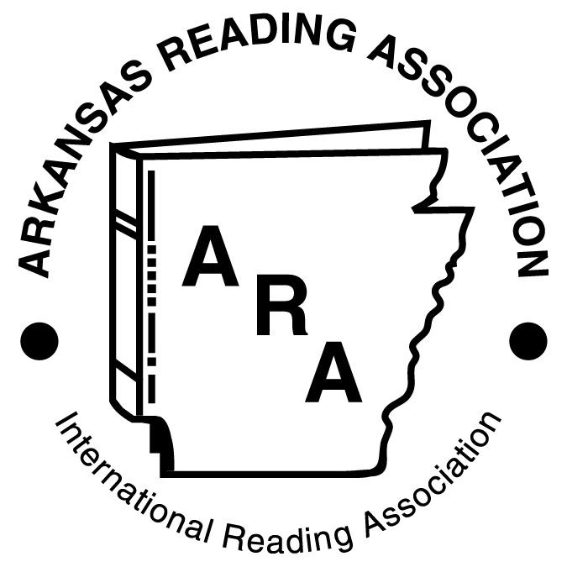  Leading the Way in Literacy
This handbook contains pertinent information for local council officers regarding officer duties, responsibilities, and deadlines. |  | 2017-18

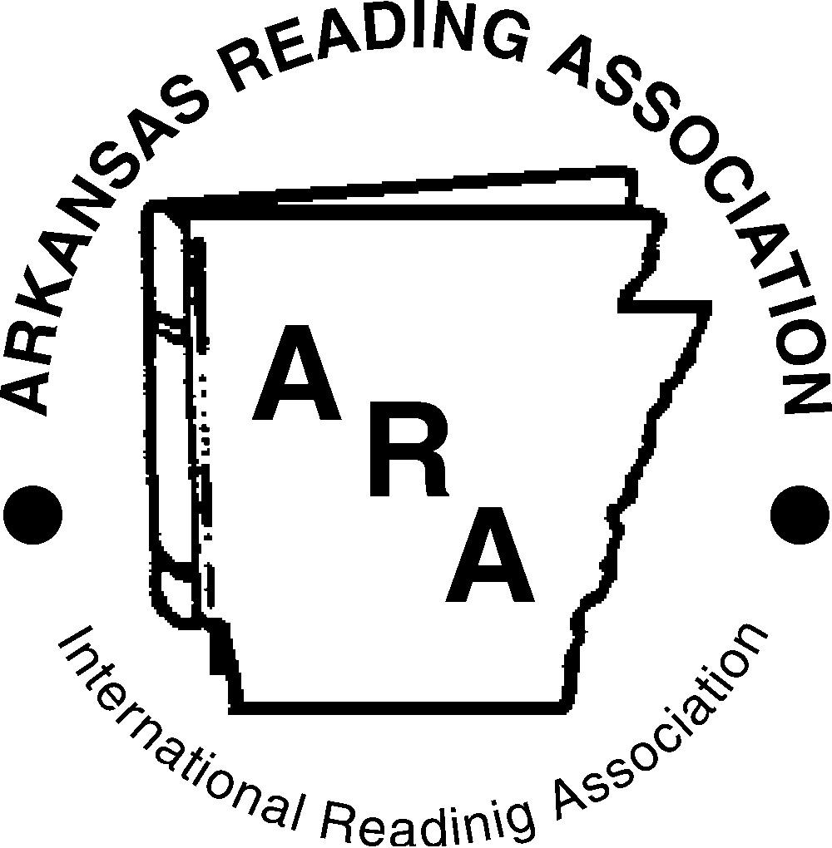
Arkansas Reading Association
An Affiliate of the International Literacy Association
2017-18 Mission and Goals

Our Mission: The Arkansas Reading Association, an affiliate of the International Literacy Association, is a professional organization of individuals, institution and councils dedicated to promoting reading and developing literacy.

Goals
PROFESSIONAL DEVELOPMENT--
Goal: Encourage the professional growth of literacy educators, particularly that of ARA members.

LONG RANGE and SHORT TERM GOALS
- Organize and support local reading councils as networks of educators of literacy
  - Provide annual Council Leadership Institute (CLI) for local council leaders
  - Provide Literacy Grant Opportunities
  - Recognize literacy volunteers (or leaders) through the Celebrate Literacy Awards
  - Provide financial incentive to local councils who achieve Honor Council
  - Provide financial incentive to councils who merit the ARA Membership Awards
  - Encourage Board member, ILA coordinator, and State Committee Chair visitation to local reading council meetings
  - Review and execute the Membership Recruitment plan
- Help educators to improve the quality of literacy instruction through publications, conferences and grant opportunities
  - Provide annual literacy conference
  - Encourage members to submit proposals for presentations at annual conference
  - Compose and distribute E-newsletter, the Reader
  - Apply for ILA Teacher Empowerment Achievement and other ILA Awards
  - Fund Jo Flanigan Scholarship
  - Fund the ARA School Based Literacy Grant
- Provide leadership in the continuously changing nature of literacy in a digital age
  - Engage in social media
  - Continuously update the ARA website

ADVOCACY--
Goal: Advocate for significant literacy issues in Arkansas that support the best interests of all learners and educators.
LONG RANGE and SHORT TERM GOALS
- Keep policy makers informed about the mission and goals of ARA/ILA
  - Provide information about ARA to State Education Committee legislators
  - Invite Legislative Education Committee members to ARA Events
(Advocacy continued)
  - Apply for ILA Public Awareness Achievement Award
- Provide members with background information and resources
  - Organize legislative session at annual conference
  - Invite key government official(s) to bring greetings at annual conference
- Collaborate with state policy makers
  - Maintain partnership with the Arkansas Department of Education

PARTNERSHIP--
Goal: Establish and strengthen partnerships with other organizations that share an interest in promoting literacy.

LONG RANGE and SHORT TERM GOALS
- Collaborate with a network of partners on long-term efforts to improve literacy
  - Sponsor ARA representatives on Charlie May Simon and AR Diamond Award Committees
  - Encourage ARA members who have recently become National Board Certified teachers to alert ARA so that we can publish our congratulations
  - Maintain partnership with AR Department of Education through appointment of ex-officio board member from ADE
  - Maintain membership booth at other state professional meetings
  - Promote and build a wide network of partnerships with organizations that share an interest in promoting literacy (AETN, Heifer International, etc…). Send conference program proposals and exhibitor information
  - Appoint ex-officio board member from our pre-service teacher population
  - Apply for ILA Community Engagement Achievement Award

RESEARCH AND COMMUNICATION--
Goal: Encourage and support research to promote informed decision-making about literacy practices and policies.
LONG RANGE and SHORT TERM GOALS
- Communicate research results through conferences and publications
  - Review, maintain and update ARA website and social media:
  - conference information
  - award information
  - newsletters
  - events
  - membership
  - archives
- Provide recognition for exemplary literacy research
  - Support the ILA Exemplary Reading Award Program
  - Fund one ARA School-based Literacy Gra
President
International Literacy Association and
Arkansas Reading Association

Local Council Officer
Job Description
The President is the leader of council and chair of the executive committee. He/she serves as a liaison between the local council and the state council. (√ ILA Requirement)
Local Council Officer Expectations: President | Completed
- Maintain Membership in Local , State, and ILA Throughout Term of Office √
- Review Council Leader Resources on ILA/ARA Websites √
- Promote Council Leader Resources on ILA/ARA Website with Council Officers
- Participate in Leadership Development Activities Offered by ILA and ARA
- Attend ARA State Conference and Participate in Council Activities
- Review Council Bylaws, Policies, Motions, Budget Reports, and Meeting Minutes in Conjunction with Executive Committee Duties
- Attend ARA Council Leadership Institute
- Facilitate Leadership Development Activities and Board Orientation for Council Leaders
- Prepare Reports as Requested
- Appoint Committee Chairpersons and Identify Committee Charges
- Monitor Progress of Committees and Achievement of Council Goals
- Review Budget and Recommendations from Board
- Schedule Board and Executive Committee Meetings
- Set Agenda for and Preside Over Board and Executive Committee Meetings
- Write President’s Message for Website, Newsletter, and/or Journal
- Confirm that All Council Officers are Members of the State/Provincial Council and ILA √
- Complete Officer Report to ARA and ILA by Due Date √

Vice President
The Vice-President is a council officer and serves on the executive committee. He/she performs the duties of the president when the president or president-elect is unavailable. (√ ILA Requirement)

Local Council Officer Expectations: Vice President | Completed
- Maintain Membership in State Council and ILA Throughout Term of Office √
- Review Council Leader Resources on ILA/ARA Website √
- Participate in Leadership Development Activities Offered by ARA
- Review Council Bylaws, Policies, Motions, Budget Reports, and Meeting Minutes in Conjunction with Executive Committee Duties
- Attend State Conference and Assist as Needed
- Attend All Council Board and Executive Committee Meetings
- Support All Council Events
- Chair or Serve On Any Committee As Requested by the President
- Attend Council Leadership Institute
- Prepare Reports as Requested by the Council Board
- Assist President With Any Delegated Duties
- Confirm that the President Submits the Officer Report to ILA by Due Date √

Membership Chairperson
The Membership Chairperson is an officer of the local council and serves on the executive committee. He/she is responsible for membership promotion, recruitment, and retention at all levels: local, state, ILA. (√ ILA Requirement)
Local Council Officer Expectations: Membership Chairperson | Completed
- Maintain Membership in Local, State, and ILA throughout Term of Office √
- Review Council Leaders’ Resources on ARA/ILA Website √
- Develop Campaign for Promoting Local, State, and ILA Membership
- Request Current ILA Member List from ARA Director of Membership for Outreach Purposes
- Attend All Local Council Board and Executive Committee Meetings
- Support All Council Activities
- Host a Membership Booth at All Council Events
- Participate in ARA Council Leadership Institute
- Attend ARA State Conference and Assist ARA Membership Chair As Needed
- Prepare Reports as Requested by the Board
- Ensure That All Council Officers are Members of the State/Provincial Council and ILA √
- Monitor ILA Membership Growth for Honor Council Award
- Collaborate with Treasurer to Ensure Accurate Processing of Membership Dues
- Maintain Accurate Membership Database √
- Send Council Membership Database to ARA
Secretary
The Secretary serves as a council officer and is a member of the executive committee. He/she maintains accurate council records and corresponds with council leaders and members. (√ ILA Requirement)
Local Council Officer Expectations: Secretary | Completed
- Maintain Membership in the Local, State, and ILA Throughout Term of Office √
- Review Council Leader Resources on ARA/ILA Website √
- Attend All Council Board and Executive Committee Meetings
- Support All Council Events
- Chair or Serve On Any Committee as Requested by the President
- Attend ARA State Conference and Assist as Needed
- Review Council Bylaws, Policies, Motions, Budget Reports, and Meeting Minutes in Conjunction with Executive Committee Duties
- Take Accurate Minutes of Each Executive Committee and Board Meeting
- Provide an Opportunity for Board to Review and Approve Meeting Minutes
- Send Meeting Minutes, Upcoming Agenda, and Notice of Next Meeting to All Board Members in Advance
- Record All Motions and Changes to Bylaws or Policy Manual as Required
- Report on All Council Correspondence Sent/Received
- Maintain Records for All Council Committees
- Archive Important Correspondence
- Coordinate the Distribution of Newsletters, Journals, etc.
- Notify Board Members and Executive Committee of Meeting Arrangements
- Send Electronic Copy of Updated Council Bylaws and Policy Manual to ILA √

Treasurer
The Treasurer serves as a council officer and is a member of the executive committee. He/she maintains accurate financial records and ensures sound fiscal management of the council. (√ ILA Requirement)
Local Council Officer Expectations: Treasurer | Completed
- Maintain Membership in the Local, State, and ILA Throughout Term of Office √
- Attend All Council Board and Executive Committee Meetings
- Support All Council Events
- Request an Informal or Formal Audit of Records Annually
- Chair or Serve On Any Committee as Requested by the President
- Attend ARA State Conference and Assist as Needed
- Attend ARA Council Leadership Institute
- Review Council Bylaws, Policies, Motions, Budget Reports, and Meeting Minutes in Conjunction with Executive Committee Duties
- Collaborate with Council Leaders to Develop a Balanced Budget √
- Update Bank Records Annually with Current Officers, Signature Cards, and Accurate EIN
- Maintain Accurate Record of Income and Expenditures √
- Ensure that all Payments are Properly Documented and Approved by the President or Designee
- Provide a Comprehensive Budget Report at Each Executive Committee and Board Meeting
- Complete Annual IRS 990 Filing by Due Date √

ANY Local Council Meeting
[DATE]

Sample Agenda

Call To Order

Welcome

Officer Reports

President [A brief summary of the action taken at the recent board meeting is
given. This is for informational purposes and may be in written form.]

Secretary [The minutes should be printed & distributed at the beginning of the
meeting or emailed ahead of time so that it is unnecessary to read them.]

Treasurer [The report should be printed and distributed at the beginning of the
meeting.]

Membership Chair [An invitation to membership is extended and a report on the
membership campaign is given.]

New Business Items Requiring a Vote By The Membership
[This would include only those items on which the general membership needs to vote.]

Program [This portion of the meeting should consume 75% of the time.]

Announcements

Adjournment

--President’s Pledge--
I promise to uphold the goals and mission of the Arkansas Reading Association and of my local council. In the event I am unable to fulfill my duties as president, I will enlist the aid of my executive board, the state coordinator, and state board members to ensure my council has a successful year

ILA Honor Council Guidelines
July 1, 2017 – June 30, 2018
Deadline: Dec. 15, 2018

Note from ILA: Official Honor Council Guidelines are on the ILA website under About Us: Awards & Grants, Honor Council Guidelines. ILA is accepting online submissions only. There will be changes but they will be minor and to the advantage of the local councils.

PART I: SERVICE TO COUNCIL MEMBERS
Required Criteria – ALL (A – B)
- Long Range Plan
  - Provide a written plan for council work. Include the mission, goals, strategies, and activities for the next one, two, or three years.
- Three Council Meetings
  - Plan and facilitate at least three council meetings during the year. Attach a summary that includes meeting dates, location, number of attendees, and topics addressed.
Optional Criteria -- CHOOSE 2 (C – I)
- Increase Council Membership
Verify increase in council membership since June of previous year. Attach June 2018 council membership list (names and email addresses) and report the level of increase from the previous year (number of members from June 2017).
- Image Brochure
Develop an image brochure that reflects the council mission, benefits of membership, and highlights affiliation with ILA and the state/provincial council.

E. Video/Slideshow
Develop a video/slideshow that highlights the council’s history and accomplishments. Explain how the video/slideshow is used to promote the council.

F. Website/Social Networking
Maintain a website or social networking site that is current, relevant, and contains up-to-date information about activities, opportunities to expand member involvement, and gives potential members access to join.
G. Newsletter
Create a newsletter or similar communication piece containing information about council activities, highlighting professional resources, and promoting membership.
H. Supporting Future/New Educators
Document council support for the professional growth of future/new educators. Examples include: college scholarships, conference registration, complimentary/ discounted memberships, providing teacher resources/instructional materials, offering meetings, workshops, webinars, institutes, etc. designed to serve future/new teachers.
- Professional Development for Council Members
Document support for the professional development of council members. Examples include: college scholarships, conference registration, offering meetings, workshops, webinars, institutes, etc. based on the current needs of council members.

PART II: SERVICE TO LOCAL COMMUNITY

No Required Criteria.

Optional Criteria -- CHOOSE 2 (A – G)
A. Celebrate Literacy
Recognize an organization, institution or individual that has made significant contributions to literacy at the local, state or provincial level with a Celebrate Literacy Award. Information regarding this award can be found on the ILA website. Accomplishments may include 1) direct teaching at any level, 2) organizing local literacy programs, 3) promoting public support relative to enhancing literacy, 4) producing teaching materials or special media for literacy programs, 5) conducting research in literacy, 6) conducting special surveys for literacy planning, 7) providing young people opportunities to help with literacy activities, and 8) conducting informal educational activities of a social, cultural, economic or political nature in which literacy activities are included. Each council should develop specific selection guidelines for the award. Recognition certificates may be requested from ILA.

B. Community Literacy Project
Organize and implement a community literacy project. Examples include: Read Across America events, reading at the mall, summer reading incentive programs, read-a-thons, etc.

C. Advocacy
Participate in advocating for significant literacy issues. Council members may be active in educating legislators or provincial officials about literacy issues pertinent to local council members. In the US local/ student/special interest council members may be involved in the ILA Legislative Action Team (LAT).
D. Family Literacy
Conduct a program or project that focuses on the important role of families in the literacy development of children.
E. Young Authors
Sponsor or cosponsor an activity that encourages, supports, and recognizes student writers in the council’s geographic area. Examples include: young authors’ contests, writing workshops, authors’ tea, writing celebrations, etc.
F. Community Service
Perform a service project that brings literacy benefits to community members. Examples include: reading in nursing homes or daycare centers, providing reading materials for use in homeless shelters, collecting magazines/books for hospital waiting rooms, assisting with adult literacy programs, etc.
G. Media Outlets in Education
Promote the use of print media for instructional purposes in the classroom and at home. Examples include: invite MOIE to a council meeting to share instructional strategies, include MOIE activities in newsletters or on council website, provide MOIE resources to schools, etc.

PART III: PARTNERSHIP WITH STATE/PROVINCIAL COUNCIL AND ILA

Required Criteria -- ALL (A – C)
- Officer Report Form
The online Officer Report Form must be submitted to ILA Headquarters between April 15 and June 30, for a council to remain in good standing and be eligible to earn Honor Council. All officers must maintain ILA membership throughout their term. The Officer Report Form is located on the ILA website.
- 10 ILA Members
Include the names and membership numbers of ten ILA members who are also members of the local, student or special interest council. Council officers may be counted in the ten ILA member requirement.
- Membership Campaign
Launch and sustain a membership campaign that promotes and increases local, student and special interest membership, as well as ARA and ILA memberships.

Optional Criteria -- CHOOSE 2 (D– H)
- New ILA Members
Increase ILA membership by at least 1 new member from July 1, 2017--June 30, 2018. Council leaders have access to the ILA membership database by logging in to the ILA website using their member number and password.
- Support State/Provincial Goals
Summarize how the council supports programs and projects that reflect the strategic plan of the state/provincial council.
- Officer Attends Local Meeting
A state board member attends a council meeting or event during the year. Any member of the ARA Board can make a council visit (virtual or in-person), including executive officers, coordinator, membership director, committee chairs, etc. Please include date of visit, type of meeting, and board representative in the summary.
- Support ILA Goals
Describe how the council supports the goals of ILA. The ILA strategic statements are located on the ILA website.
- Financial Support
Provide financial support for a council member to attend a convention, conference, leadership workshop, or other professional event sponsored by the state/provincial council or the International Literacy Association. Attach a description of the support provided, including to whom, for what, and how much.

PART IV: SERVICE TO INTERNATIONAL COMMUNITY

No Required Criteria.

Optional Criteria -- CHOOSE 2
- International Literacy Day
Participate in an International Literacy Day (September 8th) celebration.
- Help Support the Global Fund
As a member of the ILA global network, your council has the opportunity to support educators in developing countries. ILA’s global fund helps to promote literacy activities around the world. Your contribution of $100 or more can help to support future projects such as establishing libraries in Tanzania, after-school young writers clubs in Sierra Leone, reading contests in rural Bangladesh, and reading kits in Bolivia.
*If choosing this option, please make your check payable to ILA and indicate “Honor Council – Part IV B” in the memo section.

- Worldwide Literacy
Contribute to worldwide literacy effort by providing materials, funds to purchase school supplies, or assist with costs related to the professional growth of teachers. Form 4C on the ILA Honor Council webpage.
- International Literacy
Conduct a project that will promote literacy in another country. This project may involve a partnership with other agencies, such as Peace Corps, Red Cross, Rotary, etc.
- International Partnership
Establish a partnership with an international council. Examples include: sharing professional information, providing teaching resources, communicating virtually, etc.

Arkansas Reading Association
Local Council President’s Honor Council and Diamond Award Checklist, 2017-18

All of the Diamond Award Criteria are on this checklist; however, because of the options in the Honor Council program, only a partial listing is provided here. Please check your Honor Council Guidelines to ensure Honor Council status.

Dates | Activity | Contact | Award  (if applicable) | Completed
2017
July 21-22 | Attend Council Leadership Institute and Delegates’ Assembly |  | Diamond
July 22 | Plan publicity (image brochure, newsletter, etc.) | ILA | Honor
July 22 | Local Council 2017-18 Literacy Project Grant Evaluation and Receipts deadline | kaila@arareading.org
Aug. 1-15 | Recruit building ambassadors, committee chairs and plan with board
Sept. 1 | Local Council Literacy Project Grant Application deadline | kaila@arareading.org
Sept. 8 | International Literacy Day | ILA | Honor  (optional)
Sept. 15 | Submit two local council committee chair names to ARA President--one required (Celebrate Literacy) and one optional from Part II of ILA Honor Council Guidelines | kaila@arareading.org | Diamond  Honor
Sept. 15 | Submit final program calendar to ARA President (3 or more meetings) including dates, speakers, locations. After meetings submit list to ILA and include also number in attendance and topic addressed. | kaila@arareading.org | Diamond  Honor
Sept. 15 | Local Council Honoree Deadline | kaila@arareading.org
Nov. 15 | Exemplary Reading Program Applications | Kay Calvert at kay@arareading.org
Nov. 30 | Attendance of two local council representatives at ONE Delegates’ Assembly breakfast meeting –ARA Conference or CLI |  | Diamond
Dec. 15 | Submit council e-news item (one to two paragraphs) for ARA e-newsletter | kaila@arareading.org  cc:: susan@arareading.org | Diamond
Dec.15 | Honor Council Deadline for 2016-17 school year | ILA
(President’s Checklist continued.)
2018
Jan. 15 | Celebrate Literacy Award nominations to ARA Literacy Committee Chair, Rochelle Dalton. (Must submit at least one for Awards.) | rochelle@arareading.org  Rochelle Dalton | Diamond  Honor
Mar. 1 | Administrator in Reading Award Deadline | Kaila@arareading.org
Mar. 1 | Post one council news item about a meeting, event, or activity to ARA Facebook page (can be a share from your local council Facebook page). | kaila@arareading.org cc:jeanne@arareading.org | Diamond
Mar. 1 | Ensure that the local membership chair submits the following:  ____ Regular membership reports and state dues money (monthly if new members are added)  ____ Target Membership: Each One Reach One | Krista@arareading.org | Diamond
May 15  ARA | Submit name of officers for 2018-19 to ILA online https://fs6.formsite.com/intntlreading/officeform2011/index.html  (Each officer must be a member of ILA, ARA, and local council.) | jeanne@arareading.org  ILA | Diamond
Dec. 15, 2018 | Complete Honor Council submission to ILA

Summary of Arkansas Diamond Award Criteria Only, 2017-18

All documents should be sent by email, whenever possible, to the contact person listed on the chart. Questions should be directed to Kaila Murphy or Jeanne Trawick.
Contacts: Kaila Murphy, President – kaila@arareading.org;
Jeanne Trawick, Coordinator – jeanne@arareading.org;
Krista Underwood, Membership – krista@arareading.org

 | Criteria | Contact | Deadline
1 | Submit calendar of local council meetings (3 or more) including dates, speakers, and locations | kaila@arareading.org | Sept. 15, 2017
2 | Submit two local council committee chair names to ARA President -- one required (Celebrate Literacy) and one optional from Part II of ILA Honor Council Guidelines | kaila@arareading.org | Sept. 15, 2017
3 | Attendance of two local council representatives to at least one Delegates’ Assembly meeting (Council Leadership Institute or Annual Conference) | kaila@arareading.org | Nov. 30, 2017
4 | Submit council news item (one to two paragraphs) for ARA  e-newsletter | kaila@arareading.org | Dec. 15, 2017
5 | Submit at least one nominee for Celebrate Literacy Award | Rochelle@arareading.org | Jan. 15, 2018
6 | Ensure that the local membership chair submits the following:  ____ Regular membership reports and state dues money (monthly if new members are added);  ____ Target Membership -- Each One Reach One | Krista@arareading.org | March 1, 2018
7 | Post one council news item about a meeting, event, or activity to ARA Facebook page (can be a share from your local council Facebook page). | kaila@arareading.org | March 1, 2018
8 | Submit the list of local council officers for 2018-19 (must be ILA, ARA, and local council members) and complete the online information to ILA | Jeanne@arareading.org | May 15, 2018

